Vice-chancellor of BSMRAU has been elected as the member of the Association of Commonwealth Universities (ACU) Council (2015-2017)
Prof. Dr. Md. Mahbubar Rahman, vice-chancellor of Bangabandhu Sheikh Mujibur Rahman Agricultural University (BSMRAU), has been elected the executive council member of The Association of Commonwealth Universities (ACU) for the term of 2015-2017, says a press release. The ACU is a charity organisation consisting of 500 universities in 37 commonwealth countries. Queen of Britain is the chief patron of ACU. The council is the overall governing body of the ACU and is collectively responsible for overseeing the Association’s activities and determining its future direction.
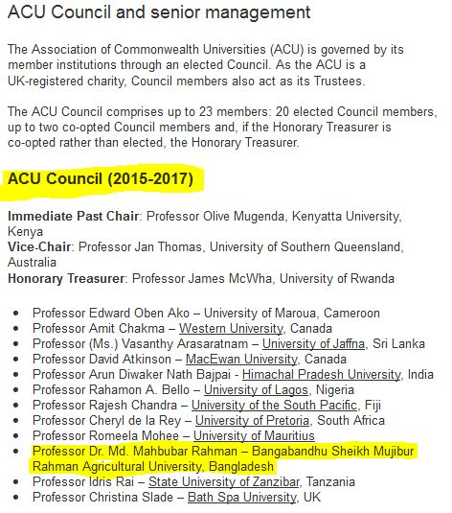
Please Click the link to see details:https://www.acu.ac.uk/about-us/council-senior-management/
http://www.theindependentbd.com/printversion/details/16770

